

**KeyKiosk**

|  |  |  |
| --- | --- | --- |
| **Supervisor:** | *LÊ THANH NHÂN* | |
| **Semester:** | *II* | |
| **Batch No:** | *T5.2306.E1* | |
| **Group No:** | *01* | |
| **Order:** | **Full name** | **Roll No.** |
| *1.* | *Nguyễn Tiến Đạt* | *Student1477469* |
| *2.* | *Nguyễn Thanh Hậu* | *Student1477167* |
| *3.* | *Phạm Tuyên* | *Student1477478* |
| *4.* | *Nguyễn Hoàng Thái* | *Student1479454* |

***Month****: 04* ***Year****: 2024*



This is to certify that

|  |  |  |
| --- | --- | --- |
| **Mr.** | **NGUYỄN TIẾN ĐẠT** |  |
| **Mr.** | **NGUYỄN THANH HẬU** |  |
| **Mr.** | **PHẠM TUYÊN** |  |
| **Mr.** | **NGUYỄN HOÀNG THÁI** |  |

Have successfully Designed & Developed

|  |  |  |
| --- | --- | --- |
|  |  |  |
| **KEYKIOSK** | | |

Submitted by:

|  |
| --- |
| **Mr. LE THANH NHAN** |

Date Of Issue:

|  |  |
| --- | --- |
|  |  |

Authorized Signature:

|  |  |
| --- | --- |
|  |  |
| **Content** | | | |

Content

Acknowledge

Synopsis

Review1 1-6

Review2 8-17

Review3 19-40

Testting Document 41

Final Checklist 42

Tasksheet 43

|  |
| --- |
| **Acknowledge** |

As we understand that the Project is a step-by- step learning environment that closely simulates the class-room and Lab based learning environment into actual implementation. It is a project implementation at your fingertips!! An electronic, live juncture on the machine that allows you to.

* Practice step by step i.e. laddered approach.
* Build a larger more robust application.
* Usage of certain utilities in applications designed by the user.
* Single program to unified code leading to a complete application.
* Learn implementation of concepts in a phased manner.
* Enhance skills and add value.
* Work on real life projects.
* Give a real life scenario and help to create applications more complicated and useful.
* Mentoring through email support.

We would like to send a great thank you to our professor and other students for the adorable support during the time in the project.

Beside several mistakes we had made in the project, we hope to have more opportunities to widen our knowledge in the web developing world.

We also thank you so much for your information and the “demo” project from India APTECH to help us get more reality experience in this project. Since we have gained more experience from this project, we will not stop learning anything as much as we can to be more successful in the future.

Your Sincerely,

Team Group 01.

|  |
| --- |
| **Synopsis** |

The Objective of this program we aim is to give a sample project to work on real

life projects. These applications help us build a larger more robust application.

The objective is not to teach us front-end or back-end technology but to provide us

with a real life scenario and help us create basic applications using the tools.

Hence, we can revise the chapters before we start with the project.

This project is meant for students like us who have completed the module of

Semester II, as well as special subjects those are Java and C#. These programs should

be done in the Lab sessions with assistance of the faculty if required.

The website (in this project) is a world that brings everything about the software account into your experience.

It is very essential for us that will have a clear understanding of the subject. We

think we should go through the project and solve the assignments as per requirements

given.

**Review 01**

|  |
| --- |
| **Problem Definition** |

In the digital era, the landscape of online services and entertainment platforms has expanded significantly, leading to increased demand for account-based trading. This trend has fueled interest in developing software solutions that support account management across various platforms such as Netflix, Spotify, Zoom, and even AI chat services such as ChatGPT.

The current challenge revolves around creating a software solution called "KeyKiosk", designed to facilitate secure and efficient account management. This requires the development of a JavaFX application that provides users with a platform to manage accounts for various online services.

Based on the needs outlined in the Project Overview, we design an application that will provide the following key features and functions:

Admin:

✓ Account Management (System account statistics management)

✓ Categories (Product category management)

✓ ProductTypes (Product type management)

✓ Products (Product Management)

✓ SoftwareAccount (Software account management)

✓ SoftwareLicenseKey (Activation key management)

✓ Orders (Order management)

✓ Dashboard (Sales statistics)

✓ Login/Register

✓ Logout.

|  |
| --- |
| **Customer Requirements Specifications** |

1. **CRS/Requirements Specifications**

|  |  |  |
| --- | --- | --- |
| **Seller Undertaken:** | | |
| 1. | List of inputs to the system | |
|  | *-* | *Register customer data.* |
|  | *-* | *Product data.* |
|  | *-* | *Order data.* |
| 2. | List of outputs expected from the system | |
|  | *-* | *Processing customer data registration.* |
|  | *-* | *Processing product data.* |
|  | *-* | *Search products from the database by category, product type...* |
|  | *-* | *Processing customer orders.* |
| 3. | Overview of processes involved in the system | |
|  | - | *Notification of customer information registration results.* |
|  | - | *Display product information.* |
|  | - | *Notify the order of results.* |
|  | - | *Results of adding new product.* |

|  |  |  |
| --- | --- | --- |
| **Admin/Project Undertaken:** | | |
| 1. | List of inputs to the system | |
|  | *-* | *Account role data.* |
| 2. | List of outputs expected from the system | |
|  | *-* | *Processing data and accounts* |
| 3. | Overview of processes involved in the system | |
|  | - | *Employee account role information.* |

|  |  |
| --- | --- |
| **Hardware and software required for implementing the project** | |
| 1. | *Operating system: Windows 10 higher.* |
| 2. | *Hardware: CPU core with RAM 2 Gigabytes or more.* |
| 3. | *Unicode fonts: Arial, Tahoma, Lucida Console, Times New Roman, etc.* |
| 4. | *Other requirements: Active internet connection* |

1. **CRS/Customer Acceptance Criteria**

|  |  |
| --- | --- |
| **S.No** | **Customer's Acceptance Criteria** |
| 1 | Given Administrator: |
| 2 | + When managing accounts, then they can view, add, edit, delete an account from the list |
| 3 | + When managing product categories, then they can view, add, edit, delete a product category from the list |
| 4 | + When managing product types, then they can view, add, edit, delete a product type from the list |
| 5 | + When managing products, then they can view, add, edit, delete a product from the list |
| 6 | + When managing software activation keys, then they can view, add, edit, delete an activation key from the list |
| 7 | + When managing banking transactions, then they can view, add, edit, delete a banking transaction from the list |
| 8 | + When managing the dashboard, then they can view sales statistics |
| 9 | Given Customer: |
| 10 | + When adding products to the cart, then they can add selected products to their shopping cart |

1. **Project Plan**

|  |  |
| --- | --- |
| 1. Project Details | |
| + | 1. Project Details |
|  | Name of the Client: KeyKiosk |
|  |  |
| + | Date of Project Plan: |
|  | 13/04/2024 |
|  |  |
| + | Project Vision/Objectives: Keykiosk |
|  | To modernize Keykiosk operations, enhancing efficiency in internal management and external transactions. Keykiosk requires a Desktop Application to oversee staff accounts with specific roles and manage customer lists along with their orders. |
|  |  |
| + | Scope: |
|  | The Desktop application for Keykiosk includes all necessary algorithms and data to provide administrators with specific roles access to the list of customers and products. Additionally, it also features functionality for placing orders to purchase products through the application. This encompasses complex data related to other data sources. |
|  |  |
| + | Our understanding of the client organization: |
|  | KeyKiosk is one of the leading businesses in Asia. Their field of operation includes trading and supplying a variety of online accounts across multiple platforms. These services are utilized not only by individual users but also by other organizations in the process of creating and managing accounts. |
|  |  |
| + | Project Organization with Responsibilities and Authorities: |
|  | *- Project Team Leader (PTL)* |
|  |  |
| 2. Project Initiation/Requirement Documents | |
|  | *- Design Documentation* |
|  | *- Installation Guide* |
|  | *- User Guide* |
|  |  |
| 3. Deliverables | |
|  | *- Design Documentation* |
|  | *- Installation Guide* |
|  | *- User Guide (include of maintenance Manual)* |
|  | *- Source Code* |
|  |  |
| 4. Project Dependencies | |
|  | *- New technology by JavaFX* |
|  |  |
| 5. Major Project Milestones | |
|  | *- Review 01* |
|  | *- Review 02* |
|  | *- Review 03* |
|  |  |
| 6. Quality Plan | |
| + | Review Activities: |
|  | *- Review meeting* |
|  | *- Development meeting* |
|  |  |
| + | Testing Activities: |
|  | *- Final meeting* |
|  |  |
| + | Backup and recovery strategies: |
| + | Review Activities: |
|  | *- Review meeting* |
|  | *- Development meeting* |
|  |  |
| + | Testing Activities: |
|  | *- Final meeting* |
|  |  |

**Review 02**

|  |
| --- |
| **Architecture and design of the Application** |

1. **Application Architecture**

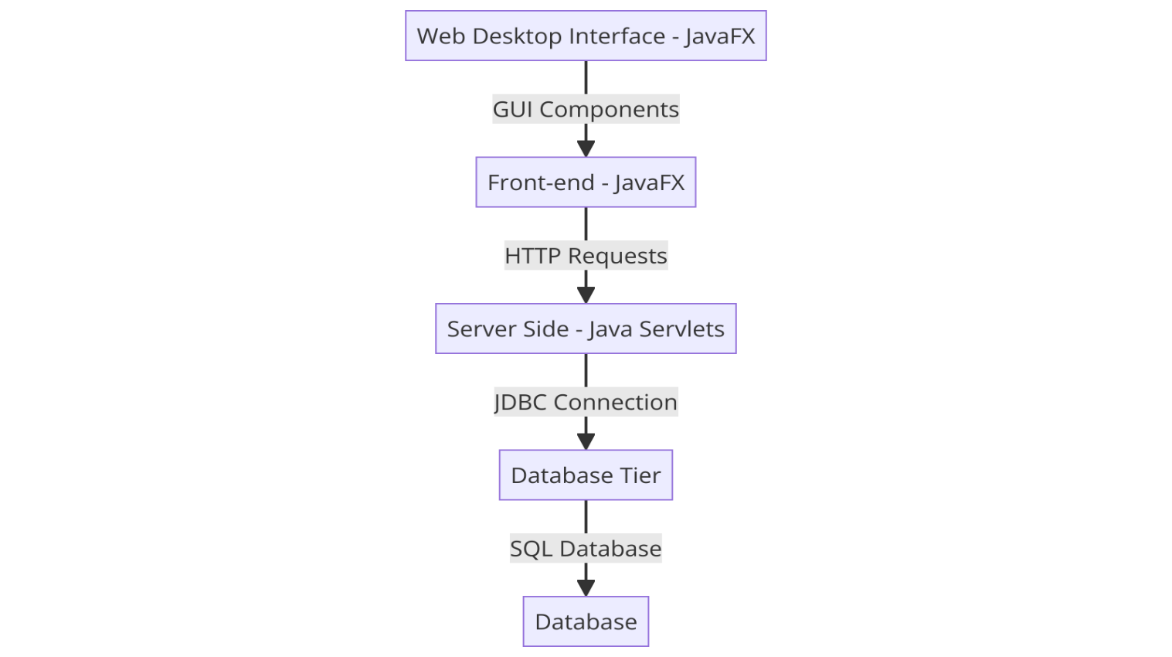

1. **Data Flow Diagram**

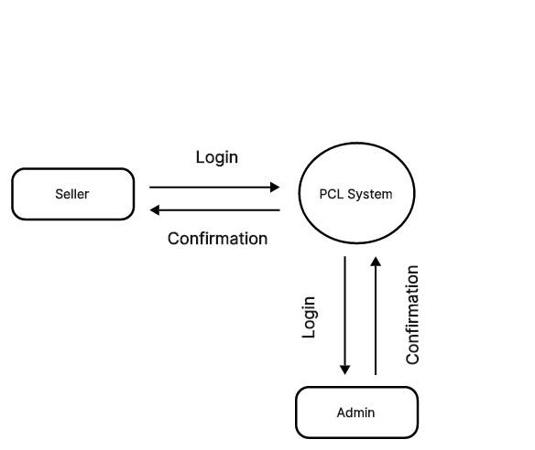

Level 0

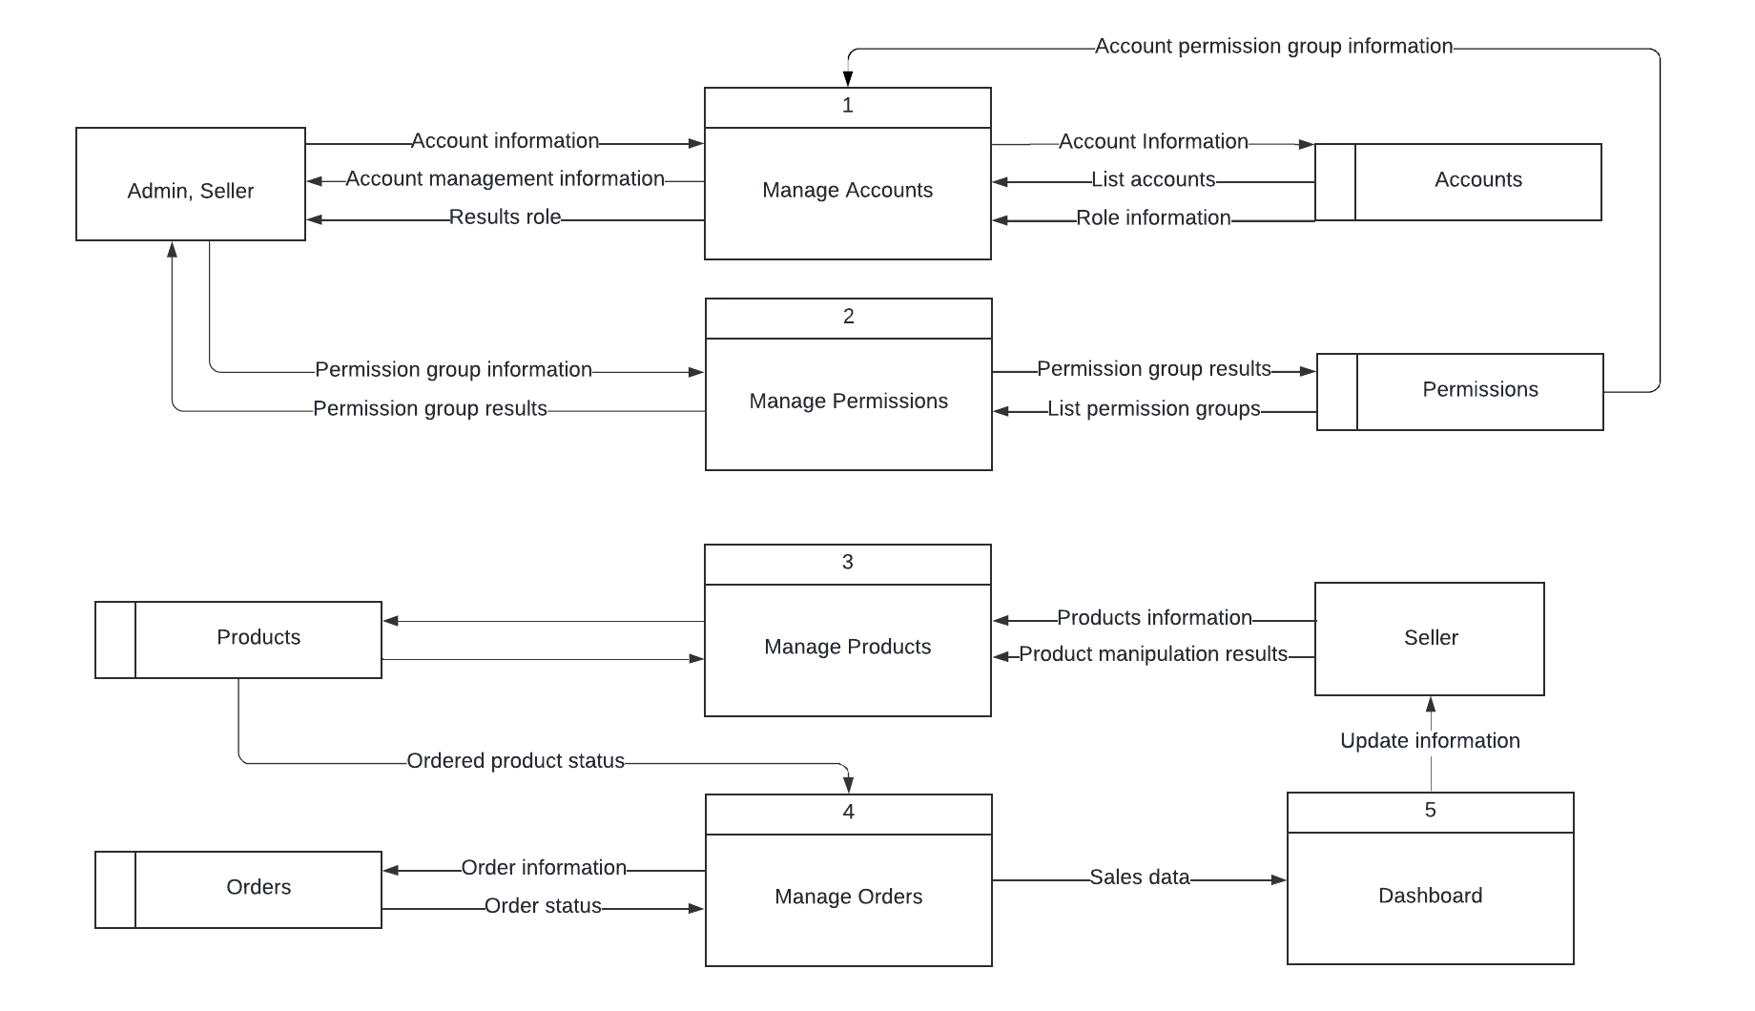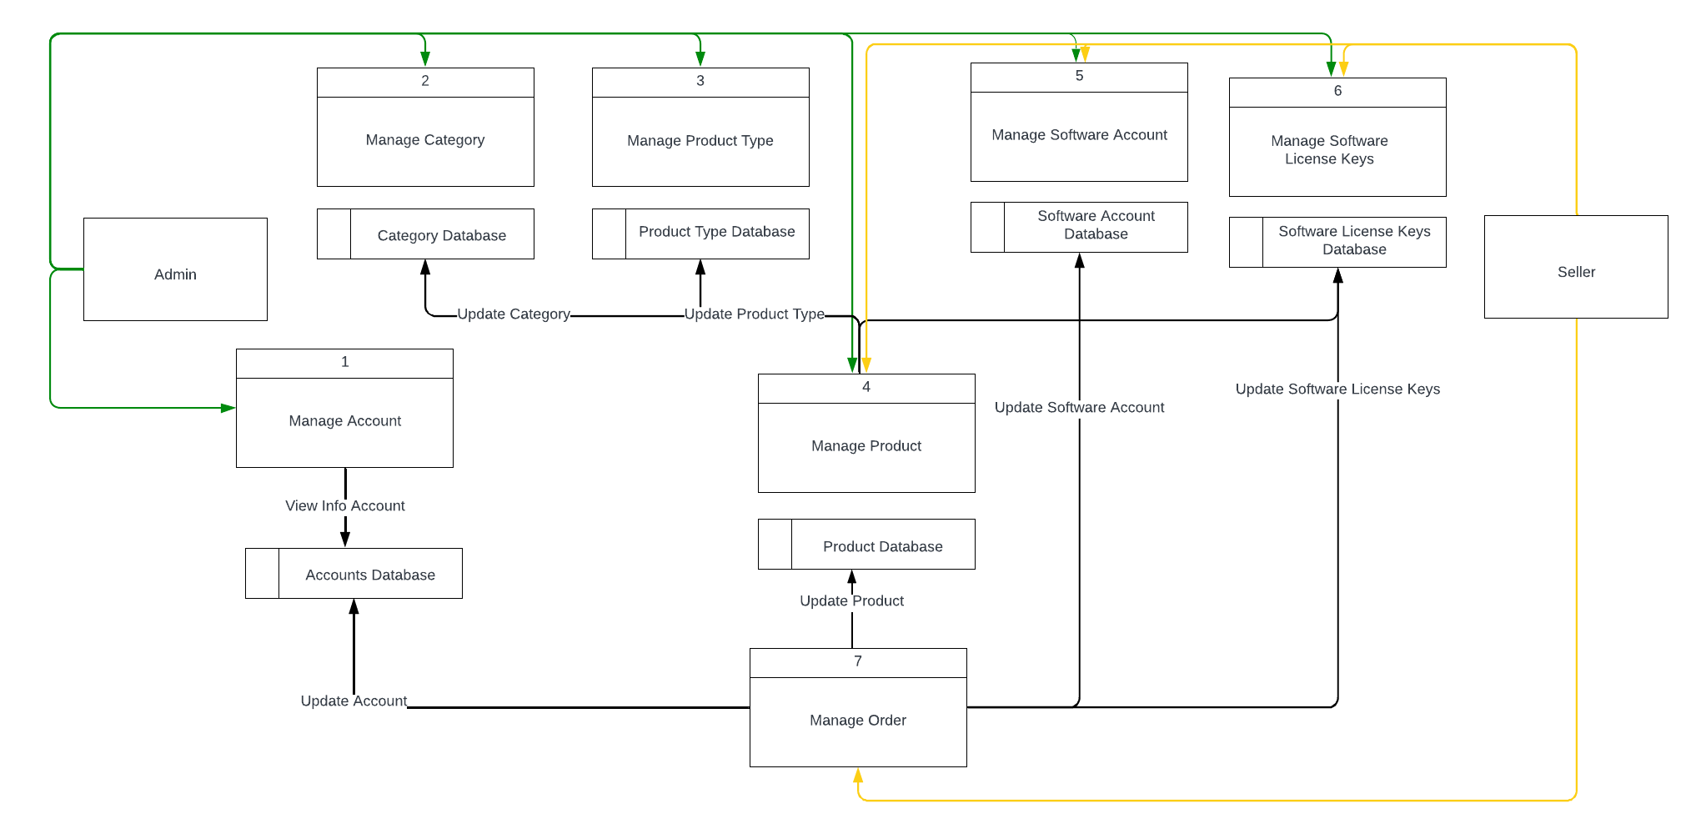

|  |
| --- |
| **Entity Relationship Diagram** |

1. **ERD**

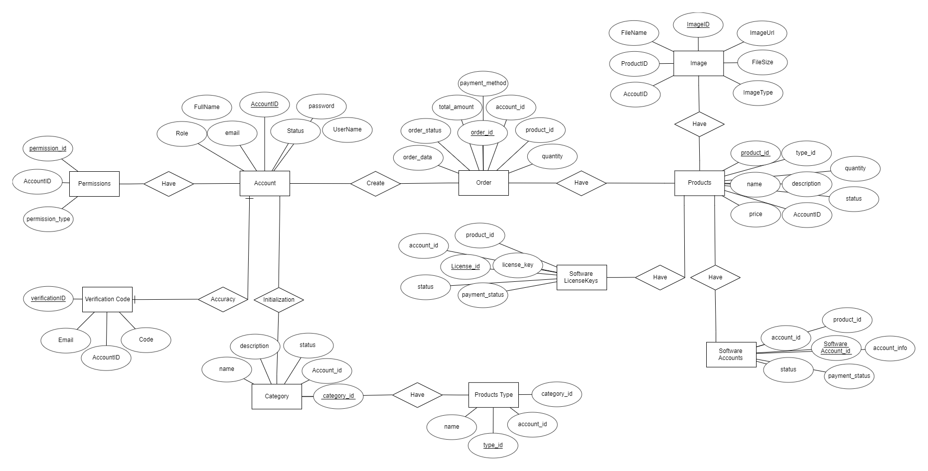

|  |
| --- |
| **Table Design** |

1. **Table Design**

|  |  |  |  |  |  |
| --- | --- | --- | --- | --- | --- |
| **Table: Accounts** | | | | | |
| **#** | **Fields** | **Data type** | **Keys** | **Constrains** | **Description** |
| 1 | account_id | bigint | Primary key | Not null | Account ID |
| 2 | username | varchar(255) |  | Not null, Unique | Username |
| 3 | password_hash | varchar(255) |  | Not null | Password |
| 4 | email | varchar(255) |  | Not null, Unique | Email address |
| 5 | full_name | varchar(255) |  | Not null | Full name |
| 6 | role | enum |  | Not null | Account role |
| 7 | status | enum |  | Not null | Account status |
|  |  |  |  |  |  |
|  |  |  |  |  |  |
| **Table: Categories** | | | | | |
| **#** | **Fields** | **Data type** | **Keys** | **Constrains** | **Description** |
| 1 | category_id | bigint | Primary key | Not null | Category ID |
| 2 | account_id | bigint | Foreign key | Not null | Link to Accounts |
| 3 | name | varchar(255) |  | Not null | Category name |
| 4 | description | text |  |  | Category description |
| 5 | status | enum |  | Not null | Category status |
|  |  |  |  |  |  |
|  |  |  |  |  |  |
| **Table: ProductTypes** | | | | | |
| **#** | **Fields** | **Data type** | **Keys** | **Constrains** | **Description** |
| 1 | type_id | bigint | Primary key | Not null | Product type ID |
| 2 | account_id | bigint | Foreign key | Not null | Link to Accounts |
| 3 | category_id | bigint | Foreign key | Not null | Link to Categories |
| 4 | name | varchar(255) |  | Not null | Product type name |
|  |  |  |  |  |  |
| **Table: Products** | | | | | |
| **#** | **Fields** | **Data type** | **Keys** | **Constrains** | **Description** |
| 1 | product_id | bigint | Primary key | Not null | Product ID |
| 2 | type_id | bigint | Foreign key | Not null | Link to ProductTypes |
| 3 | account_id | bigint | Foreign key | Not null | Link to Accounts |
| 4 | name | varchar(255) |  | Not null | Product name |
| 5 | description | text |  |  | Product description |
| 6 | price | numeric(38, 2) |  | Not null | Product price |
| 7 | quantity | int |  | Not null | Quantity in stock |
| 8 | status | enum |  | Not null | Product status |
|  |  |  |  |  |  |
| **Table: SoftwareAccounts** | | | | | |
| **#** | **Fields** | **Data type** | **Keys** | **Constrains** | **Description** |
| 1 | software_account_id | bigint | Primary key | Not null | Software account ID |
| 2 | account_id | bigint | Foreign key | Not null | Linked to Accounts |
| 3 | product_id | bigint | Foreign key | Not null | Linked to Products |
| 4 | account_info | text |  | Not null | Software account information |
| 5 | status | enum |  | Not null | Account status |
| 6 | payment_status | enum |  | Not null | Payment status |
|  |  |  |  |  |  |
| **Table: SoftwareLicenseKeys** | | | | | |
| **#** | **Fields** | **Data type** | **Keys** | **Constrains** | **Description** |
| 1 | license_id | bigint | Primary key | Not null | License key ID |
| 2 | account_id | bigint | Foreign key | Not null | Link to Accounts |
| 3 | product_id | bigint | Foreign key | Not null | Link to Products |
| 4 | license_key | text |  | Not null | License key value |
| 5 | status | enum |  | Not null | License key status |
| 6 | payment_status | enum |  | Not null | Payment status |
|  |  |  |  |  |  |
| **Table: Orders** | | | | | |
| **#** | **Fields** | **Data type** | **Keys** | **Constrains** | **Description** |
| 1 | order_id | bigint | Primary key | Not null | Order ID |
| 2 | account_id | bigint | Foreign key | Not null | Link to Accounts |
| 3 | product_id | bigint | Foreign key | Not null | Link to Products |
| 4 | quantity | int |  | Not null | Quantity product |
| 5 | payment_method | enum |  | Not null | Method of payment |
| 6 | total_amount | numeric(38, 2) |  | Not null | Total amount |
| 7 | order_status | enum |  | Not null | Order status |
| 8 | order_data | datetime |  | Not null | Oder date and time |
|  |  |  |  |  |  |
| **Table: Images** | | | | | |
| **#** | **Fields** | **Data type** | **Keys** | **Constrains** | **Description** |
| 1 | image_id | bigint | Primary key | Not null | Image ID |
| 2 | category_id | bigint | Foreign key | Not null | Photo uploader Linked to Categories |
| 3 | product_id | bigint | Foreign key | Not null | Photo uploader Linked to Products |
| 4 | account_id | bigint | Foreign key | Not null | Photo uploader Linked to Accounts |
| 5 | image_url | varchar(255) |  |  | URL where the image is stored |
| 6 | image_type | Enum |  | Not null | Type of the image |
| 7 | file_name | varchar(100) |  |  | Original file name of the image |
| 8 | file_size | varchar(255) |  |  | Size of the image file in bytes |
|  |  |  |  |  |  |
|  |  |  |  |  |  |
| **Table: Verification Code** | | | | | |
| **#** | **Fields** | **Data type** | **Keys** | **Constrains** | **Description** |
| 1 | verification_code_id | bigint | Primary key | Not null | Verification Code ID |
| 2 | account_id | bigint | Foreign key | Not null | Link to Accounts |
| 3 | code | varchar(255) |  |  | Verification Code |
| 4 | email | varchar(255) |  | Not null | Email |
|  |  |  |  |  |  |
| **Table: Permissions** | | | | | |
| **#** | **Fields** | **Data type** | **Keys** | **Constrains** | **Description** |
| 1 | permission_id | bigint | Primary key | Not null | Permission ID |
| 2 | account_id | bigint | Foreign key | Not null | Link to Accounts |
| 3 | permission_type | varchar(255) |  |  | Type of rights managed |
| 4 | permission_id | bigint | Primary key | Not null | Permission ID |

1. **Relationship Diagram**

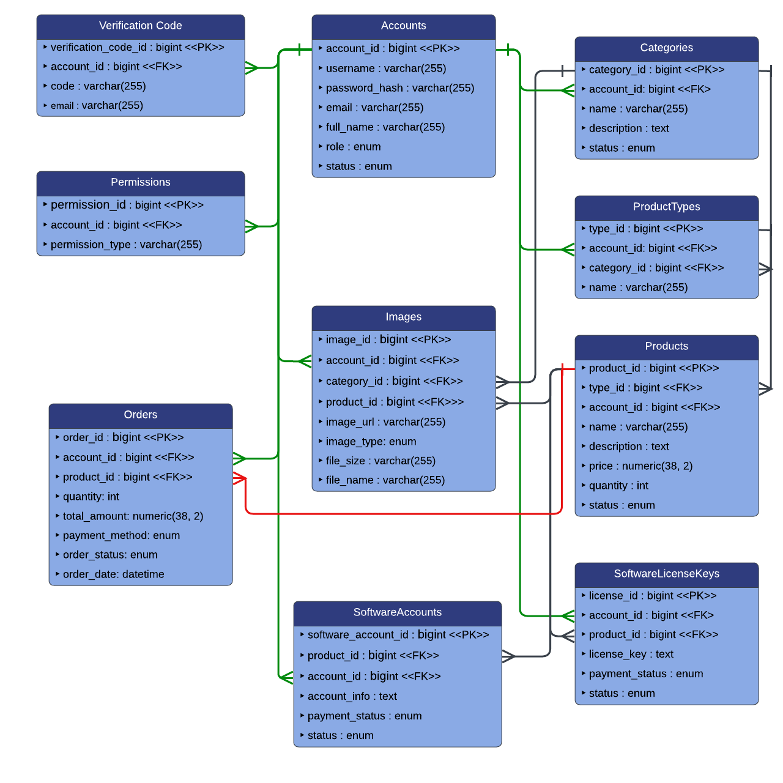

|  |
| --- |
| **Algorithm** |

1. **Admin**

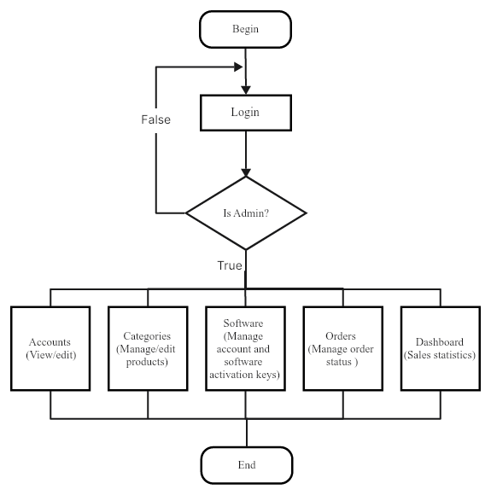

1. **Seller**

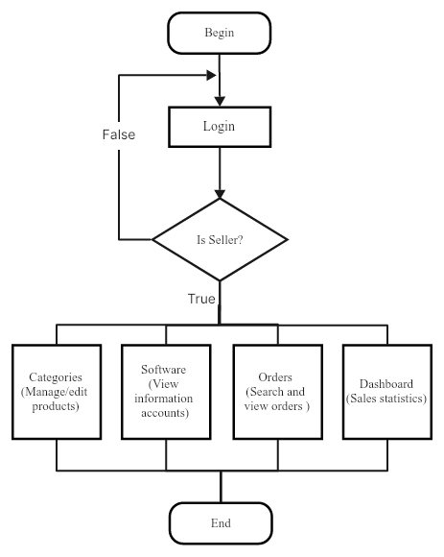

**Review 03**

|  |
| --- |
| **Screen shots** |

1. **Order**

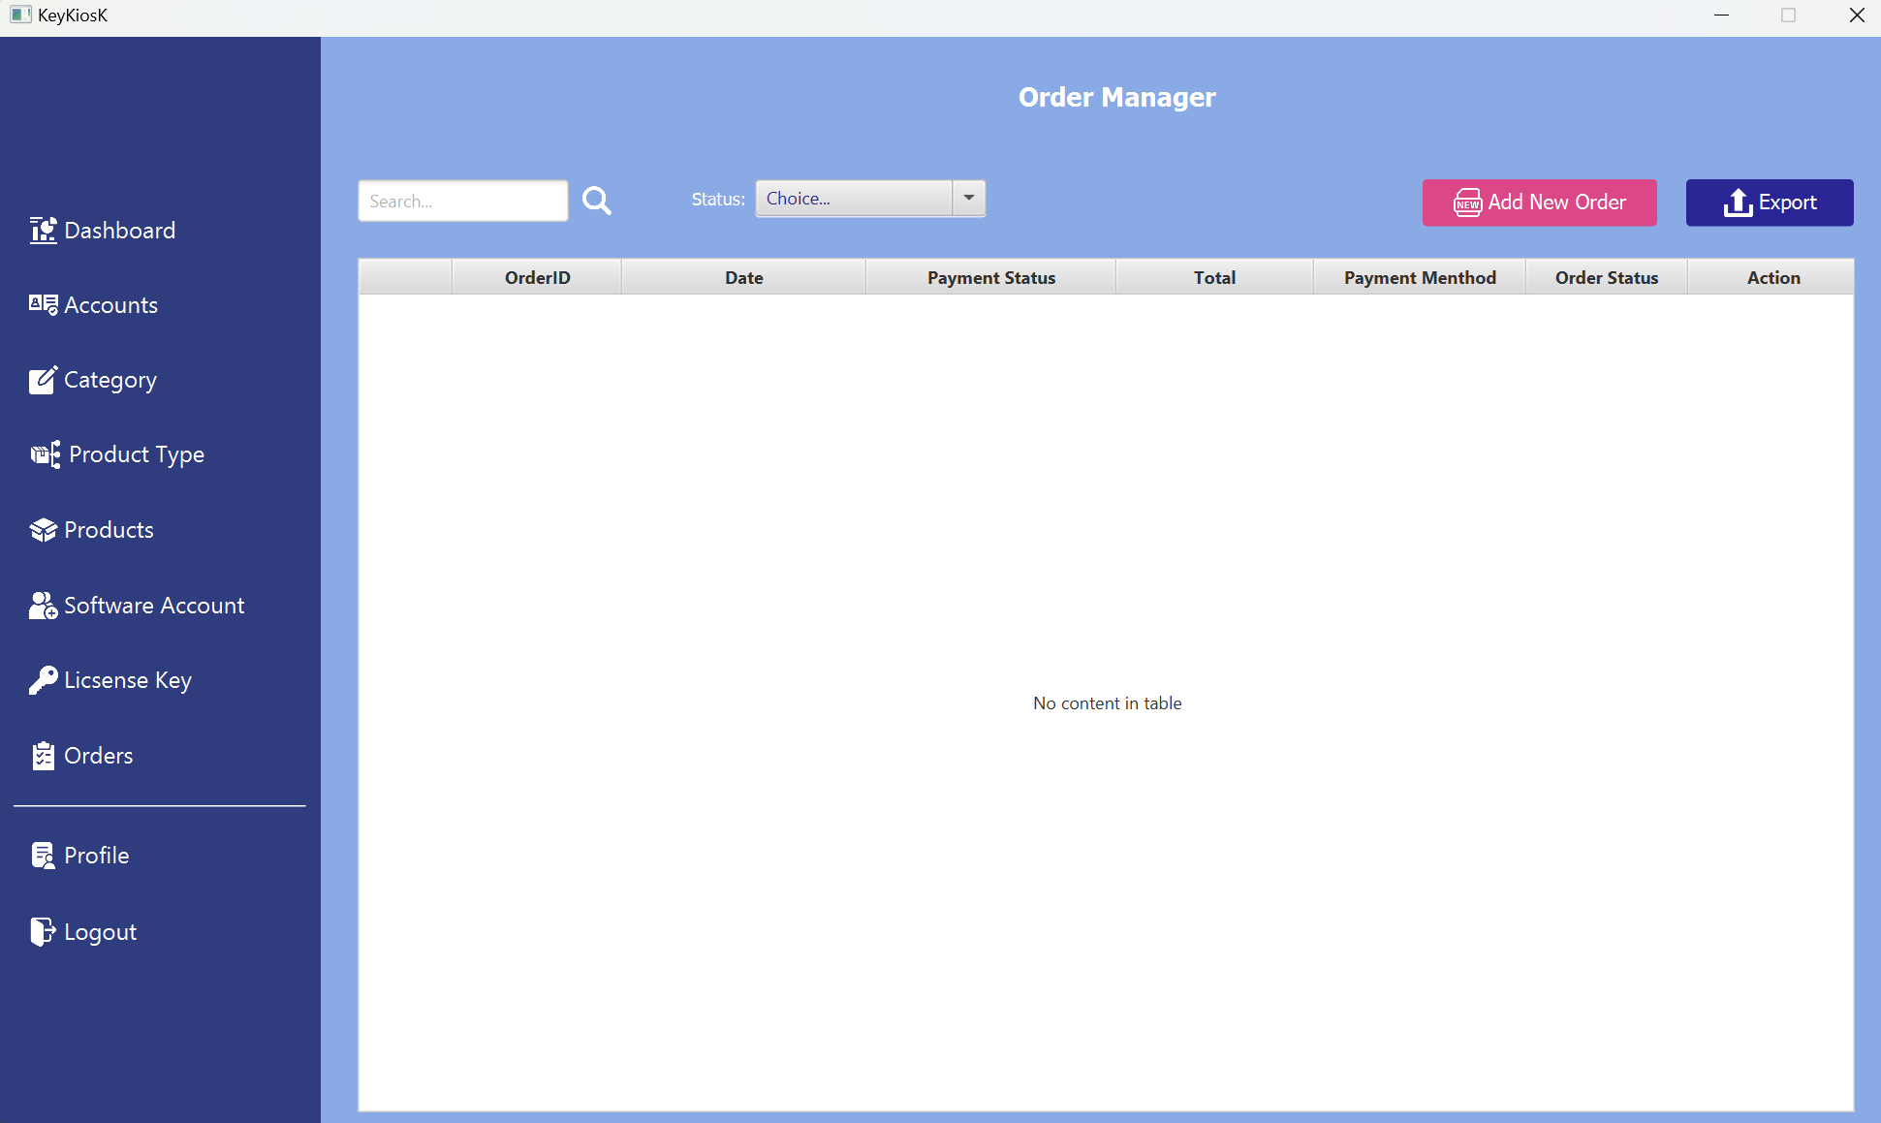

**Description** : This page allows users to view invoices, add new invoices, edit invoices, delete invoices, and also export invoices.

**From** : This page can be opened from any tab within the app.

**To** :This page can navigate to any tab.

|  |  |
| --- | --- |
| **Properties** | **Value** |
| Document theme and color scheme | Management of account and software sales |
| Form - Background color | Tahoma - #8AAAE5 |
| Title - Font Size | 16px |
| Title - Font Color | #FFFFFF |
| Title - Font Style | Bold |
| Title - Alignment | Centered |
| Background color of Controls on the form | #2F3C7E, #DB4787, #292594 |
| Foreground color of Controls on the form | #2F3C7E |
| Control Caption -- Font size | 16px |
| Control Caption - Font Color | #2F3C7E |
| Control Caption - Font Style | Bold |
| Control caption and controls - Alignment | Centered |
| Command button - Alignment | Centered |

1. **Products**

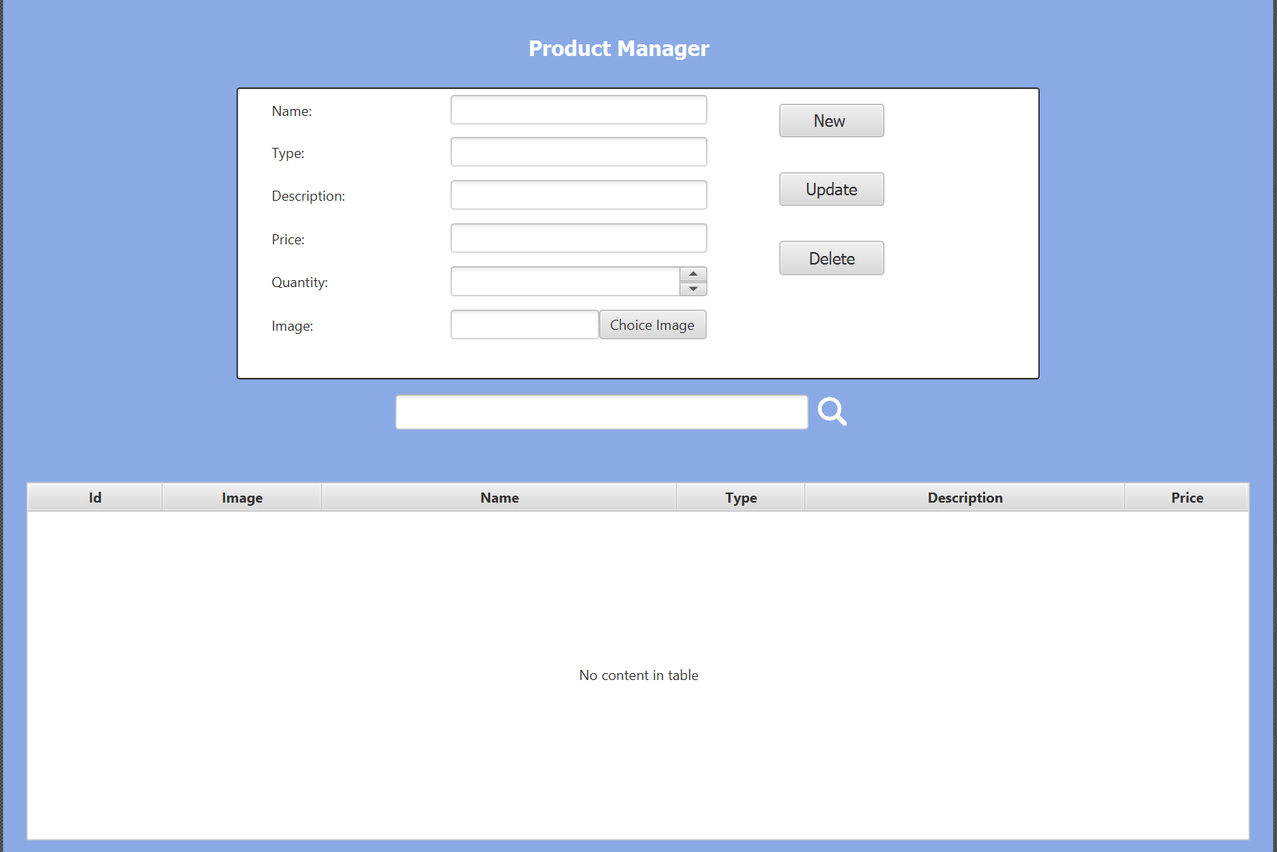

**Description** : This page allows viewing the entire list of products and enables additional actions such as viewing more details, editing, and deleting all products.

**From** : This page can be opened from any tab within the app.

**To** : This page can navigate to any tab.

|  |  |
| --- | --- |
| **Properties** | **Value** |
| Document theme and color scheme | Management of account and software sales |
| Form - Background color | Tahoma - #8AAAE5 |
| Title - Font Size | 16px |
| Title - Font Color | #FFFFFF |
| Title - Font Style | Bold |
| Title - Alignment | Centered |
| Background color of Controls on the form | #2F3C7E |
| Foreground color of Controls on the form | #2F3C7E |
| Control Caption -- Font size | 16px |
| Control Caption - Font Color | #2F3C7E |
| Control Caption - Font Style | Bold |
| Control caption and controls - Alignment | Centered |
| Command button - Alignment | Centered |

1. **Product Type**

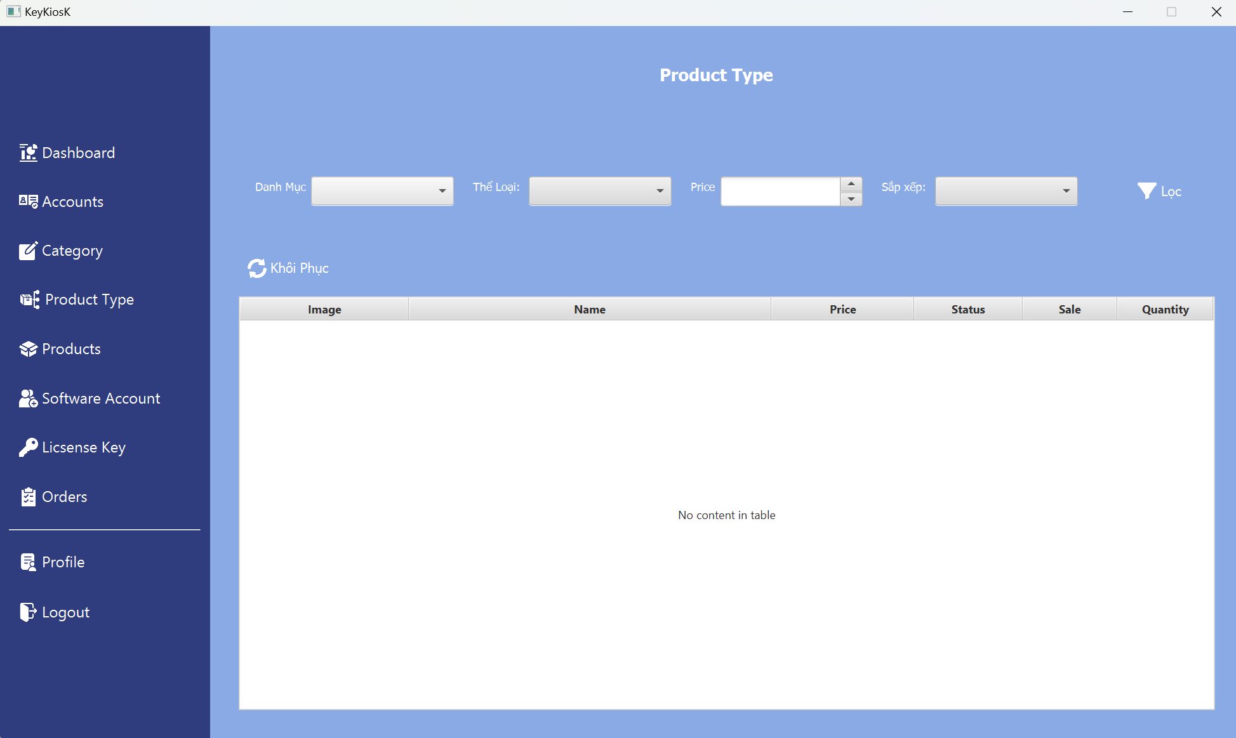

**Description** : This page enables viewing all products, as well as searching and sorting products by their product type.

**From** : This page can be opened from any tab within the app.

**To** : This page can navigate to any tab.

|  |  |
| --- | --- |
| **Properties** | **Value** |
| Document theme and color scheme | Management of account and software sales |
| Form - Background color | Tahoma - #8AAAE5 |
| Title - Font Size | 16px |
| Title - Font Color | #FFFFFF |
| Title - Font Style | Bold |
| Title - Alignment | Centered |
| Background color of Controls on the form | #2F3C7E |
| Foreground color of Controls on the form | #2F3C7E |
| Control Caption -- Font size | 16px |
| Control Caption - Font Color | #2F3C7E |
| Control Caption - Font Style | Bold |
| Control caption and controls - Alignment | Centered |
| Command button - Alignment | Centered |

1. **Software License Keys**

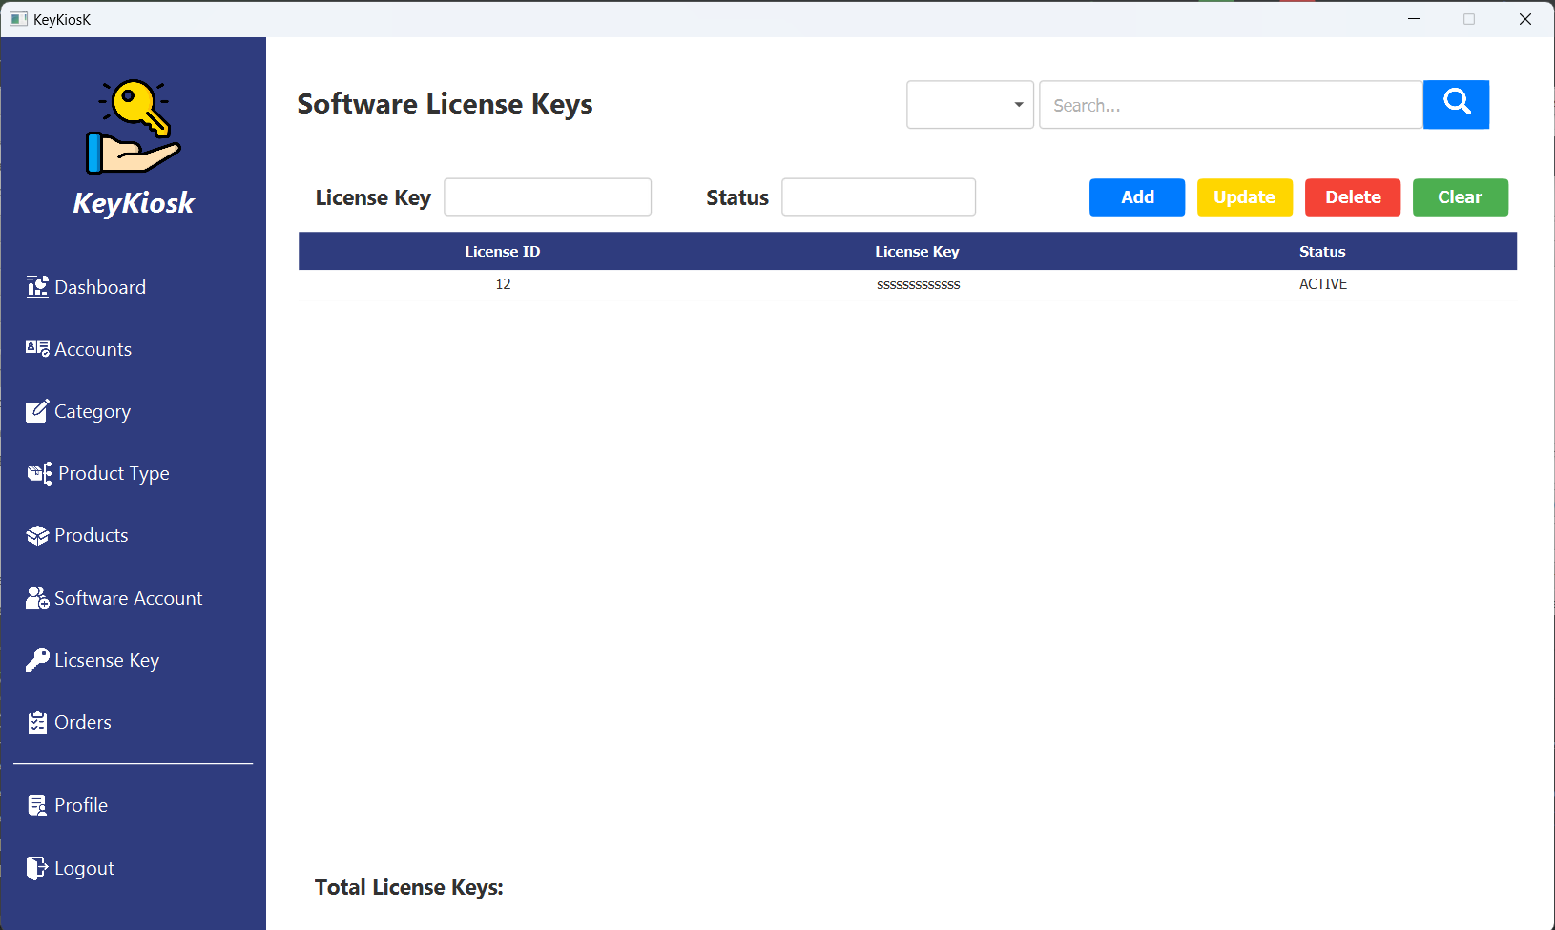

**Description** : Software License Keys page, This page manage information about software activation keys added by the seller.

**From** : This page can be opened from any tab within the app.

**To** : This page can navigate to any tab.

|  |  |
| --- | --- |
| **Properties** | **Value** |
| Document theme and color scheme | Software License Keys # 17131E |
| Form - Background color | Family System - # FFFFFF |
| Title - Font Size | 24px |
| Title - Font Color | # 2F3C7E |
| Title - Font Style | Bold |
| Title - Alignment | Centered |
| Background color of Controls on the form | #2F3C7E |
| Foreground color of Controls on the form | #2F3C7E |
| Control Caption -- Font size | 16px |
| Control Caption - Font Color | #2F3C7E |
| Control Caption - Font Style | Bold |
| Control caption and controls - Alignment | Centered |
| Command button - Alignment | Centered |

1. **Dashboard.**

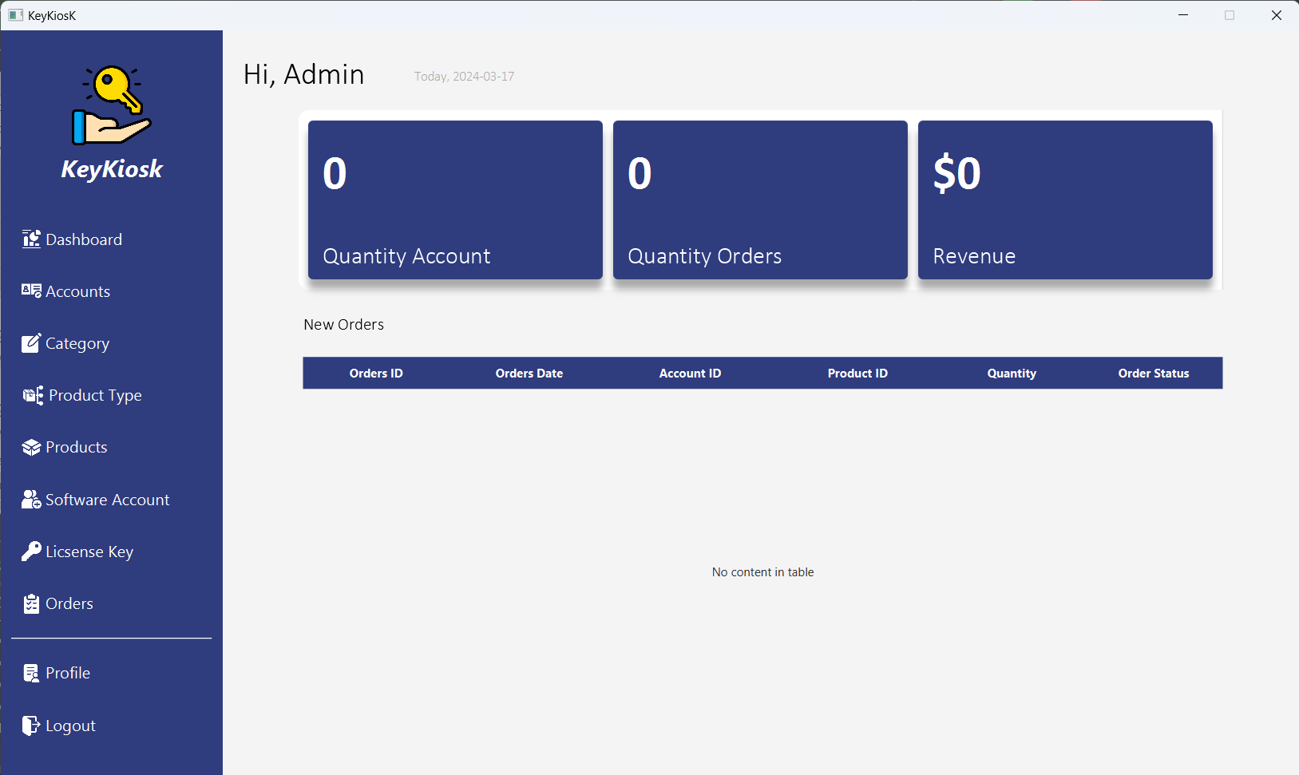

**Description** : Dashboard page, This page online store management

**From** : This page can be opened from any tab within the app.

**To** : This page can navigate to any tab

|  |  |
| --- | --- |
| **Properties** | **Value** |
| Document theme and color scheme | Dashboard # 17131E |
| Form - Background color | Family System - # FFFFFF |
| Title - Font Size | 24px |
| Title - Font Color | # 2F3C7E |
| Title - Font Style | Bold |
| Title - Alignment | Centered |
| Background color of Controls on the form | #2F3C7E |
| Foreground color of Controls on the form | #2F3C7E |
| Control Caption -- Font size | 16px |
| Control Caption - Font Color | #2F3C7E |
| Control Caption - Font Style | Bold |
| Control caption and controls - Alignment | Centered |
| Command button - Alignment | Centered |

1. **Profile**

**Description:** This is the main Profile page. This page is listed allowing users to view their personal information. When clicking the Edit Profile button, you will be redirected to the Profile Settings page to change information including changing the password.

**From:** This page can be opened from any tab within the app.

**To:** This page can navigate to any tab

|  |  |
| --- | --- |
| **Properties** | **Value** |
| Document theme and color scheme | Profile |
| Form - Background color | Tahoma -#f8f7f7 |
| Title - Font Size | 50px |
| Title - Font Color | #f8f7f7 |
| Title - Font Style | Bold |
| Title - Alignment | Center-LEFT |
| Background color of Controls on the form | #2F3C7E |
| Foreground color of Controls on the form | #2F3C7E |
| Control Caption -- Font size | 15px |
| Control Caption - Font Color | #000000 |
| Control Caption - Font Style | Bold |
| Control caption and controls - Alignment | Center-LEFT |
| Command button - Alignment | Center-LEFT |

1. **Software Account**

**Description:** This page listed allows users to view and update their personal information, including changing their password.

**From**: This page can be opened from any tab within the app.

**To**: This page can navigate to any tab.

|  |  |
| --- | --- |
| **Properties** | **Value** |
| Document theme and color scheme | Software Account |
| Form - Background color | Tahoma - #282525 |
| Title - Font Size | 30px |
| Title - Font Color | #282525 |
| Title - Font Style | Bold |
| Title - Alignment | Center-LEFT |
| Background color of Controls on the form | #2F3C7E, #F3F3F3, #4CAF50,#3F51B5,#f44336,  #6610f2,#4b0082 |
| Foreground color of Controls on the form | #2F3C7E |
| Control Caption -- Font size | 14px |
| Control Caption - Font Color | #2F3C7E |
| Control Caption - Font Style | Bold |
| Control caption and controls - Alignment | Center-LEFT |
| Command button - Alignment | Center-LEFT |

1. **Login**

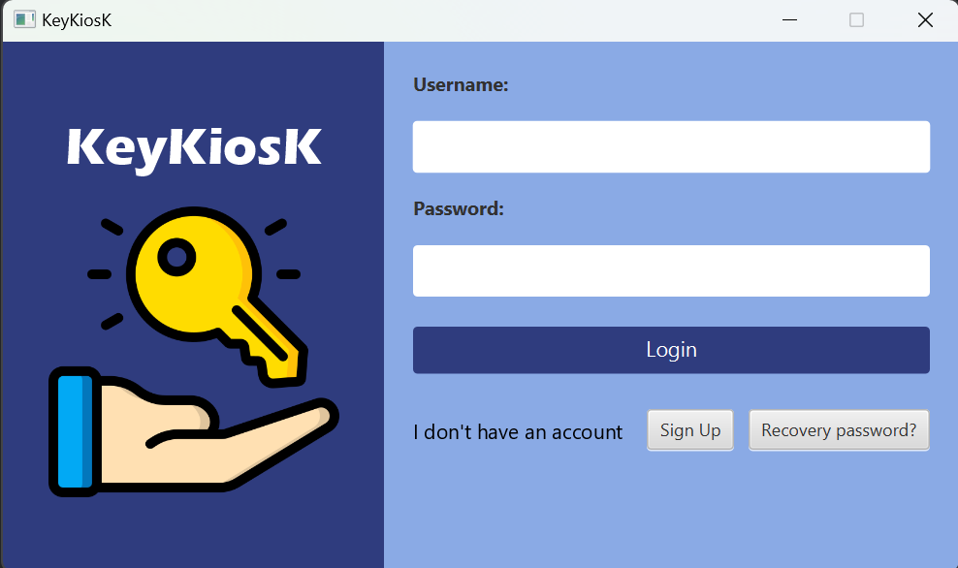

**Description:** This page appears upon launching the application. Its purpose is to authenticate the user's identity and permissions through a username and password.

**From:** This page can be opened from any tab within the app.

**To:** This page can navigate to any tab.

|  |  |
| --- | --- |
| **Properties** | **Value** |
| Document theme and color scheme | Login #2F3C7E |
| Form - Background color | #FFFFFF |
| Title - Font Size | 1.2em |
| Title - Font Color | #FFFFFF, #000000 |
| Title - Font Style | Bold |
| Title - Alignment | Centered Left |
| Background color of Controls on the form | #FFFFFF, #2F3C7E |
| Foreground color of Controls on the form | #FFFFFF |
| Control Caption -- Font size | 1.2em |
| Control Caption - Font Color | #000000 |
| Control Caption - Font Style | Bold |
| Control caption and controls - Alignment | Centered Left |
| Command button - Alignment | Centered |

1. **Account**

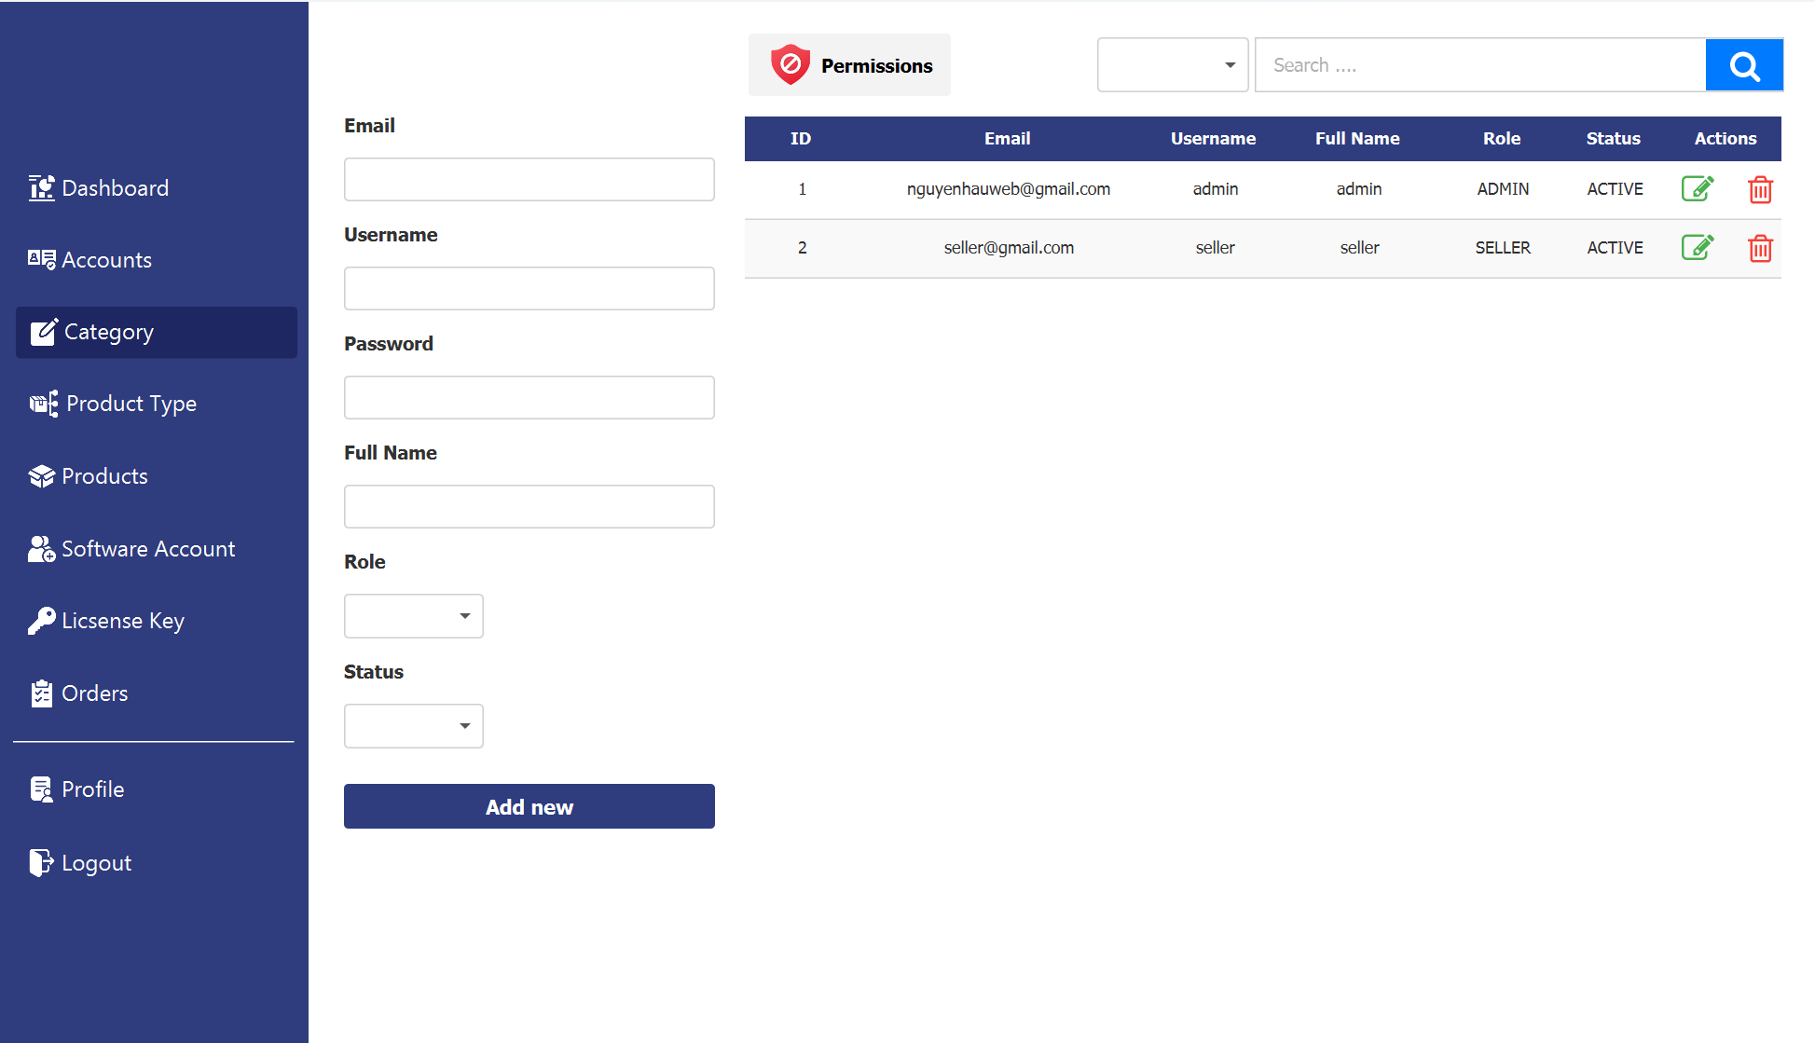

**Description:** This page is used to manage accounts and is accessible only to administrators.

**From:** This page can be accessed from any tab within the app.

**To:** This page can navigate to any tab

|  |  |
| --- | --- |
| **Properties** | **Value** |
| Document theme and color scheme | Manage account #2F3C7E |
| Form - Background color | #FFFFFF |
| Form - Border olor | #2F3C7E |
| Title - Font Size | 1.2em |
| Title - Font Color | #FFFFFF |
| Title - Font Style | Bold |
| Title - Alignment | Centered Left |
| Background color of Controls on the form | #FFFFFF, #2F3C7E |
| Foreground color of Controls on the form | #FFFFFF |
| Control Caption -- Font size | 1.2em |
| Control Caption - Font Color | #3b3b3b |
| Control Caption - Font Style | Bold |
| Control caption and controls - Alignment | Centered Left |
| Command button - Alignment | Centered |

1. **Category**

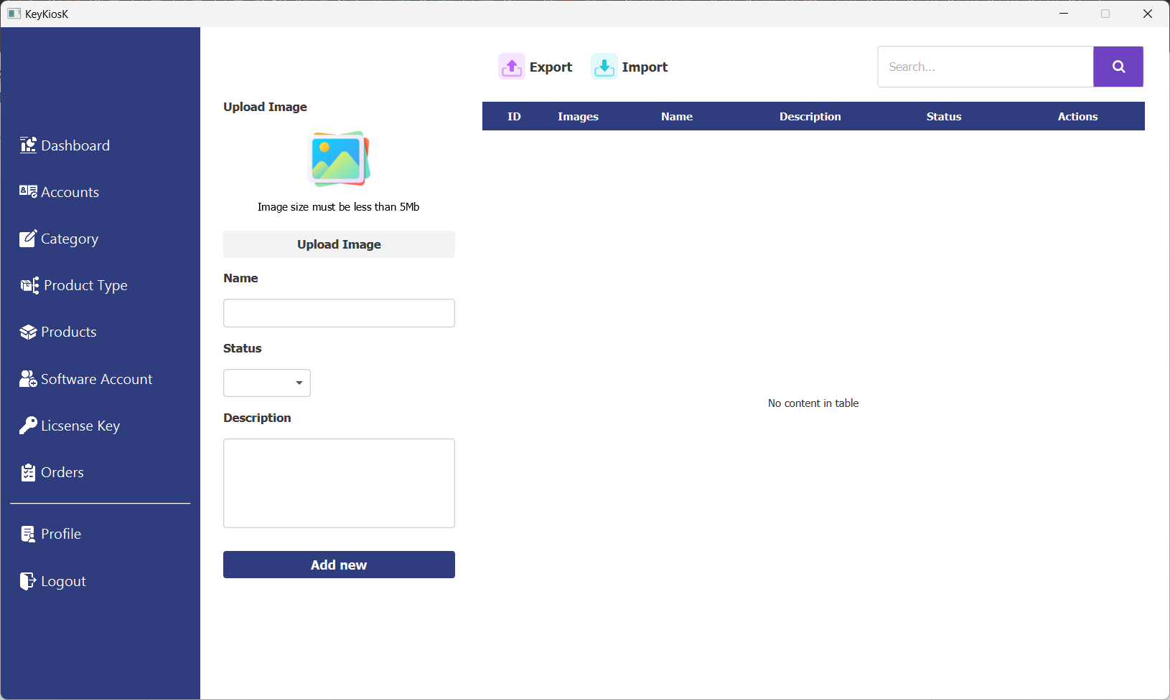

**Description:** This page is used to manage product categories.

**From:** This page can be accessed from any tab within the app.

**To:** This page can navigate to any tab

|  |  |
| --- | --- |
| **Properties** | **Value** |
| Document theme and color scheme | Manage categories #2F3C7E |
| Form - Background color | #FFFFFF |
| Form - Border olor | #2F3C7E |
| Title - Font Size | 1.2em |
| Title - Font Color | #FFFFFF |
| Title - Font Style | Bold |
| Title - Alignment | Centered Left |
| Background color of Controls on the form | #FFFFFF, #2F3C7E |
| Foreground color of Controls on the form | #FFFFFF |
| Control Caption -- Font size | 1.2em |
| Control Caption - Font Color | #3b3b3b |
| Control Caption - Font Style | Bold |
| Control caption and controls - Alignment | Centered Left |
| Command button - Alignment | Centered |

1. **Profile Settings**

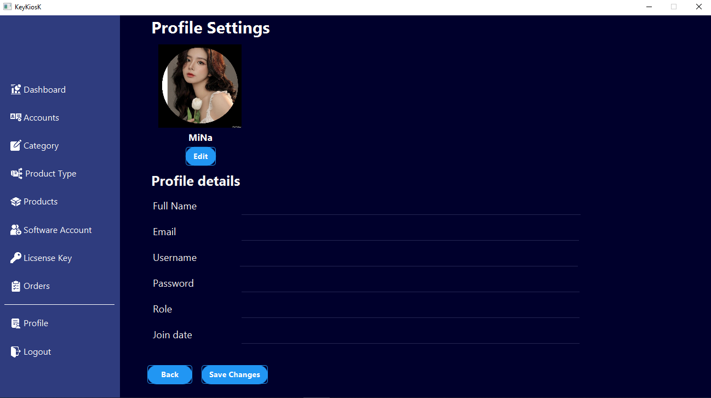

**Description:** This is the Profile Settings page. This page is for changing information including changing the password. When you click the Back button, you will be redirected to the main Profile page.

**From:** This page can be opened from any tab within the app.

**To:** This page can navigate to any tab.

|  |  |
| --- | --- |
| **Properties** | **Value** |
| Document theme and color scheme | Profile Settings |
| Form - Background color | Tahoma -#f8f7f7 |
| Title - Font Size | 30px |
| Title - Font Color | #f8f7f7 |
| Title - Font Style | Bold |
| Title - Alignment | Center-LEFT |
| Background color of Controls on the form | #2F3C7E |
| Foreground color of Controls on the form | #2F3C7E |
| Control Caption -- Font size | 15px |
| Control Caption - Font Color | #2F3C7E |
| Control Caption - Font Style | Bold |
| Control caption and controls - Alignment | Center-LEFT |
| Command button - Alignment | Center-LEFT |

|  |
| --- |
| **Testing document** |

|  |  |  |
| --- | --- | --- |
| **Sr.No** | **Features Tested** | **Remarks** |
| 1 | Login Functionality | Passed: Users can successfully log in with valid credentials. |
| 2 | Viewing Products | Passed: Users can view a list of existing products without any issues. |
| 3 | Adding a New Product | Passed: Users can add new products to the inventory without any issues. |
| 4 | Adding a New Product | Passed: Users can edit the details of existing products without any issues. |
| 5 | Deleting a Product | Passed: Users can delete products from the inventory as expected. |
| 6 | Search Functionality | Passed: The search feature returns accurate results as expected. |
| 7 | Sorting Products | Passed: Users can sort the products based on different criteria (e.g., name, price) successfully. |
| 8 | Filtering Products | Passed: Users can filter products based on specific criteria (e.g., category, availability) without any issues. |
| 9 | Exporting Products | Passed: The exporting feature functions properly and exports products in the desired format. |
| 10 | User Permissions | Passed: User permissions are properly enforced, restricting access to certain features based on user roles. |
| 11 | Image Upload | Passed: Users can upload product images without any issues. |
| 12 | Product Categories | Passed: Products are organized into categories as expected. |
| 13 | Data Validation | Passed: Data validation checks have been improved, minimizing the risk of input errors. |
| 14 | Performance Testing | Passed: The user interface is intuitive and easy to navigate. |
| 15 |  |  |

|  |
| --- |
| **Final checklist** |

|  |  |  |
| --- | --- | --- |
| **Sr.No** | **Aspected Tested** | **Suggestion/**  **Remarks** |
| 1 | Are all the users able to view the images and links? | Yes |
| 2 | Have all the views, modules and controllers been properly integrated and is the site function as a single page application? | Yes |
| 3 | Are the GUI content devoid of spelling mistakes? | No |
| 4 | Is the application user-friendly? | Yes |
| 5 | Is the Website launching correctly in all popular browsers? | Yes |
| 6 | Are all the forms validated with proper criteria? | Yes |
| 7 | Do all text links lead to the appropriate website? | Yes |
| 8 | Do all image links lead to the appropriate website? | Yes |
| 9 | Are all the images and links clearly visible on the page? | Yes |
| 10 | Does the Web page work properly in all the tested browsers? | Yes |
| 11 | Does the Web page take too long to be loaded fully? | No |
| 12 | Is the navigation sequences correct through all the Web pages on the site? | Yes |
| 13 | Is the JavaScript code working as expected in all click events? | Yes |

|  |  |  |  |  |  |  |  |  |  |
| --- | --- | --- | --- | --- | --- | --- | --- | --- | --- |
| **No** | **Member** | **Contents** | | **Table Name** | **Activity Plan** | **Date of Preparation of Activity Plan** | | |  |
| **Planed Start Date** | **Actual Start Date** | **Actual Days** | **Status** |  |
| 1 | **Nguyễn Tiến Đạt** | Admin | *Product Manager* | Products, Order, Product Type | 13/04/2024 | 13/04/2024 | 5 | OK |  |
| 2 | *Order Manager* | 13/04/2024 | 13/04/2024 | 5 | OK |  |
| 3 | *Product Type Manager* | 13/04/2024 | 13/04/2024 | 5 | OK |  |
| 4 | Seller | *Product* | 13/04/2023 | 13/04/2024 | 5 | OK |  |
| 5 | *Product Type* | 13/04/2023 | 13/04/2024 | 5 | OK |  |
| 6 | *Order* | 13/04/2024 | 13/04/2024 | 5 | OK |  |
|  |  |  |  |  |  |  |  |  |  |
| 1 | **Nguyễn Thanh Hậu** | Admin | *Account management* | Account,  Login, Category | 13/04/2023 | 13/04/2024 | 5 | OK |  |
| 2 | *Category* | 13/04/2023 | 13/04/2024 | 5 | OK |  |
| 4 | Seller | *Login* | 13/04/2023 | 13/04/2024 | 5 | OK |  |
| 5 | *Category* | 13/04/2023 | 13/04/2024 | 5 | OK |  |
|  |  |  |  |  |  |  |  |  |  |
| 1 | **Phạm Tuyên** | Admin | *Software Account* | Software Account, Profile | 13/04/2023 | 13/04/2024 | 5 | OK |  |
| 2 | *Profile* | 13/04/2023 | 13/04/2024 | 5 | OK |  |
| 3 | Seller | *Software Account* | 13/04/2023 | 13/04/2024 | 5 | OK |  |
| 4 | *Profile* | 13/04/2023 | 13/04/2024 | 5 | OK |  |
|  |  |  |  |  |  |  |  |  |  |
| 1 | **Nguyễn Hoàng Thái** | Admin | *Software LicenseKeys* | LiscenseKeys,  Dashboard | 13/04/2023 | 13/04/2024 | 5 | OK |  |
| 2 | *Dashboard* | 13/04/2023 | 13/04/2024 | 5 | OK |  |
| 3 | Seller | *Software LiscenseKeys* | 13/04/2023 | 13/04/2024 | 5 | OK |  |
| 4 | *Dashboard* | 13/04/2023 | 13/04/2024 | 5 | OK |  |